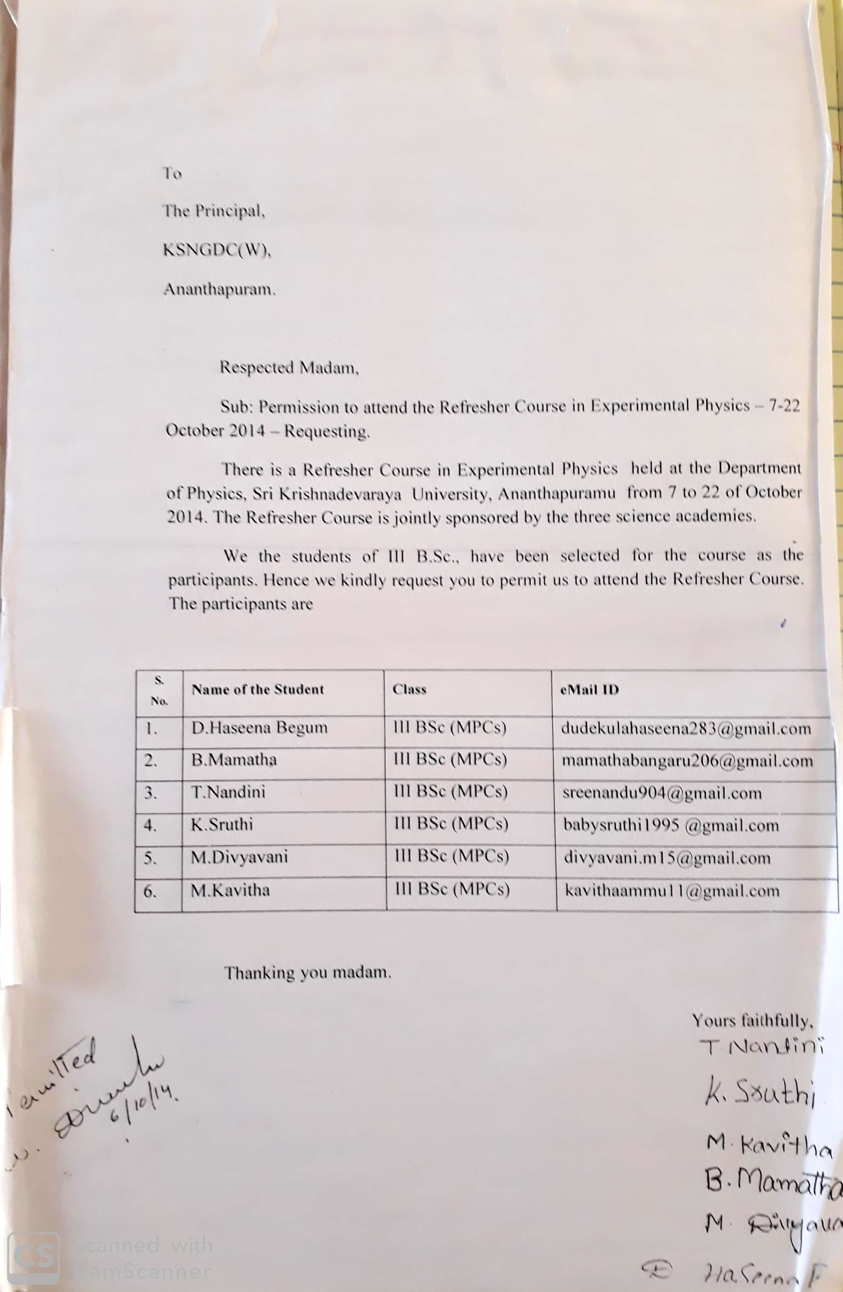

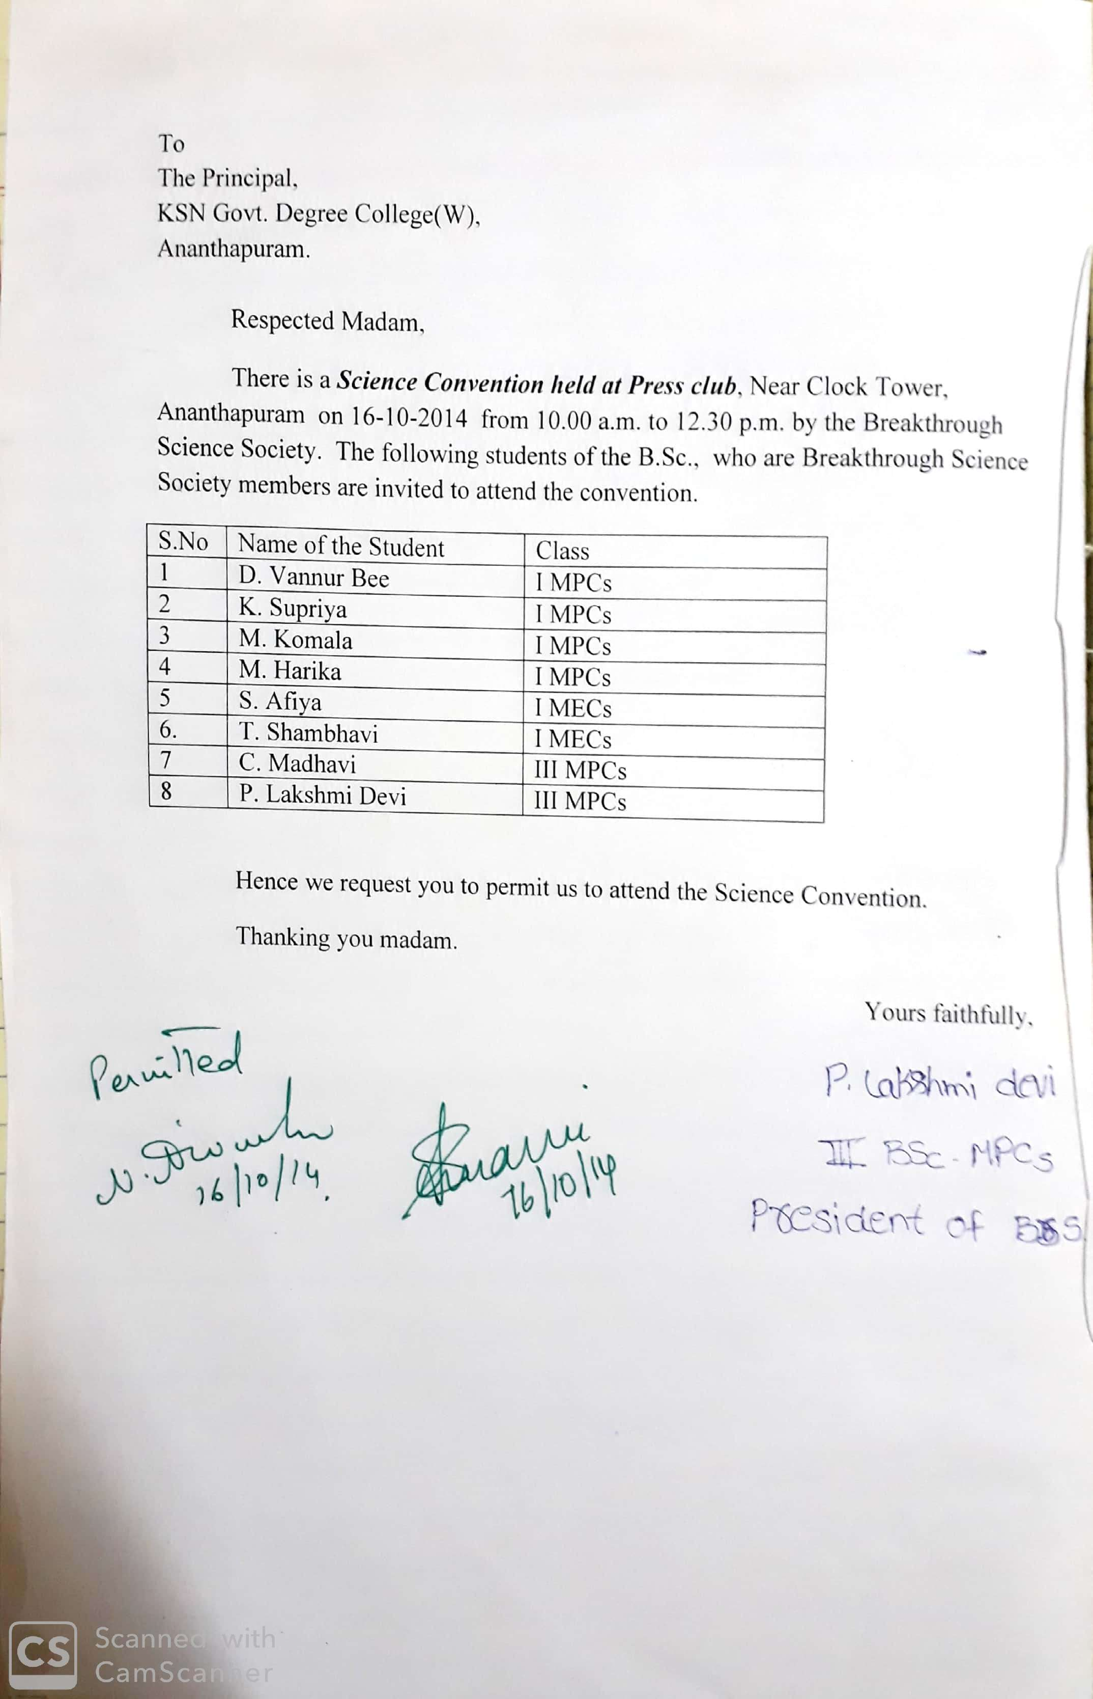

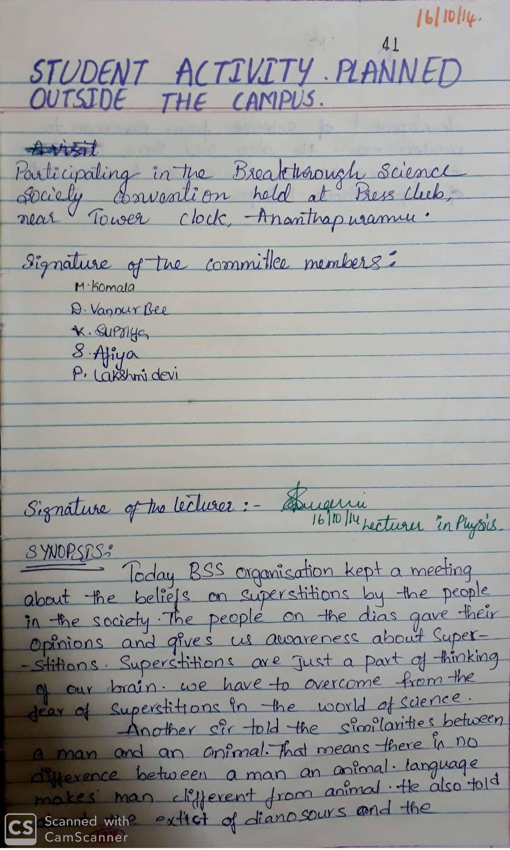

**Distribution of provisions from the funds raised by the students at**

**Andha Mahila Ashramam, Kurugunta, Anantapur 4-11-2015**

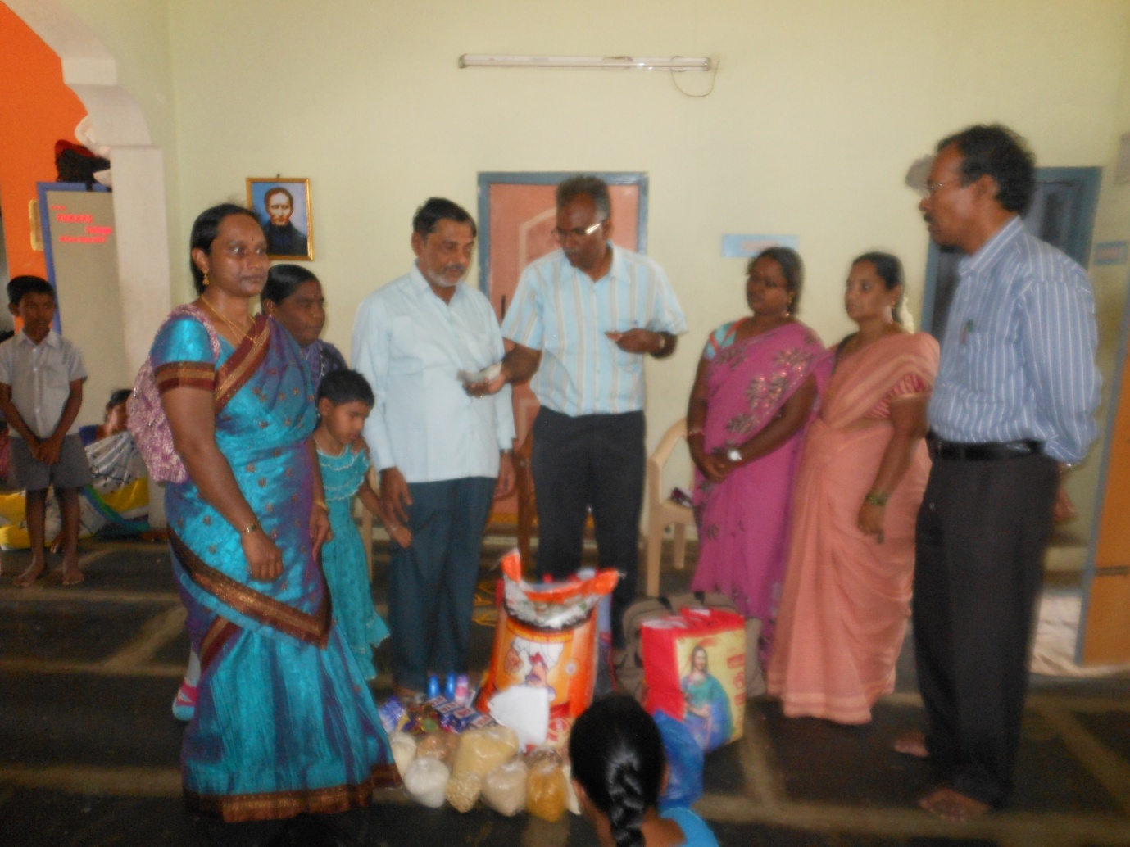

Republic Day Celebrations 26-1-2016

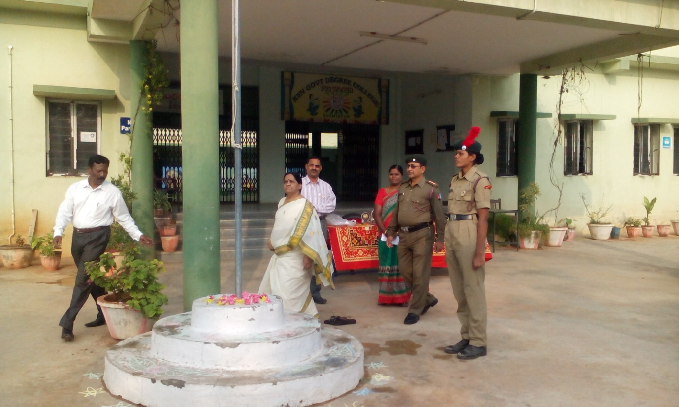

Smt. Bhavani, Youth Welfare Officer, delivering a message to the students on “Beti Bachavo-Beti padaavo” 26-1-2016

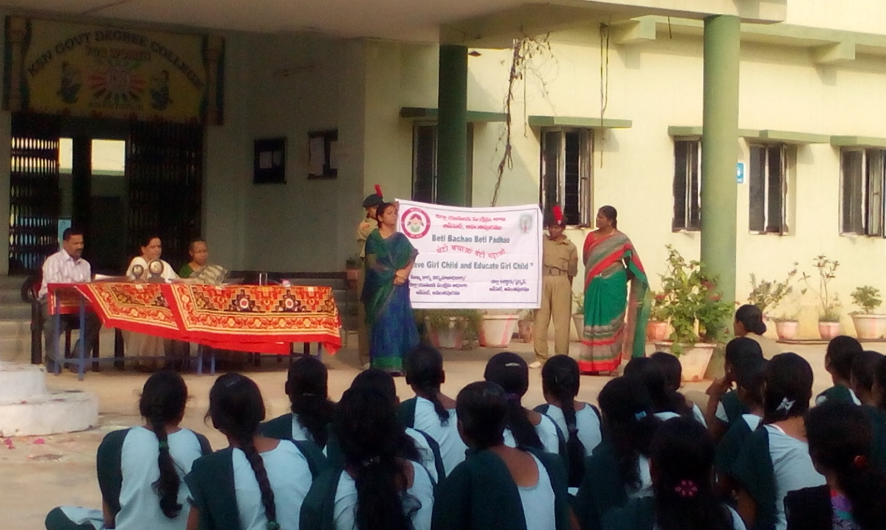

**District level Quiz programme ( D.R.C. Sponsored) on Disaster Management Organized by Department of Physical Sciences 27-1-2016**

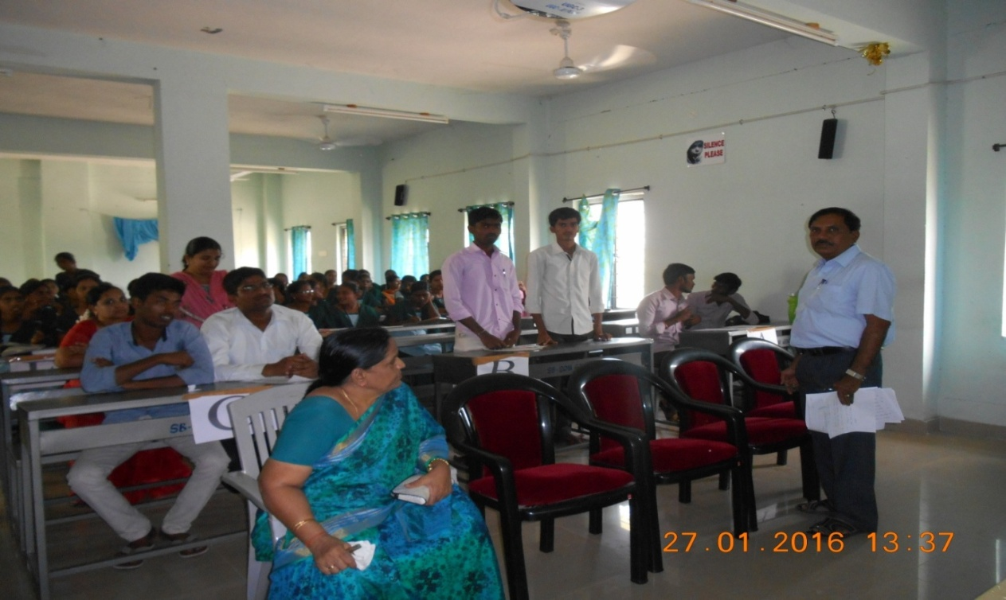

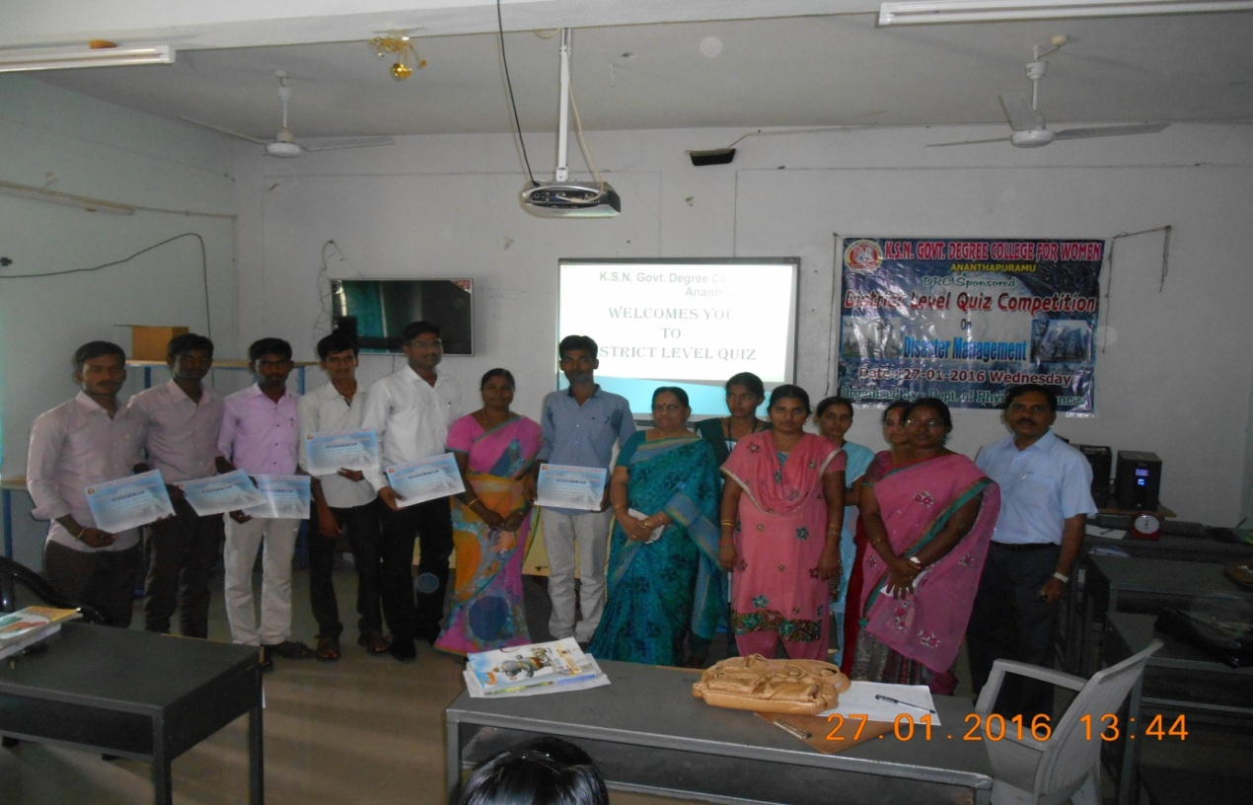

**TISS - Inaugural Function - Dr. S. Padmavathi, Principal, addressing the Students 3-2-2016**

